Revision Assessment -1
Case study
The history of Indian Railways dates back to over 160 years ago. On 16th April 1853, the first passenger train ran between Bori Bunder (Bombay) and Thane, a distance of 34 km. It was operated by three locomotives, named Sahib, Sultan and Sindh, and had thirteen carriages.
1. People crowd at the gate of the train to
a) get down fast
b) enjoy the wind on their faces
c) both a and b
d) neither of these
2. Safai Karamchari helps to
a) maintain law and order
b) book ticket
c) carry luggage
d) clean railways
3. We should go to a _____if we donot feel safe in trains.
a) coolie b)RPF c) sweeper d)porter
4. The train driver is also known as
a) T.T.E b) ticket seller c) guard d)loco pilot
5. Line of sight joins the
a)object and train
b)object and window
c)object and eye
c)object and railway tracks
Choose the correct option:
6. Khejadi tree is well known for it’s medicinal qualities, which of its part have medicinal benefits?
a. Roots
b. Bark
c. Leaf
d. Fruit
7. The state in which you live, comes in which type of landform?
a. Plain
b. Desert
c. Plateau
d. Coastal area
8. Statement: Honey bees are social insects and have clear division of labour.
Reason: Any type of honey bee can do any kind of work as per wish.
- Statement is correct but reason is not justified.
b. statement is incorrect but reason is justified.
c. Both statement and reasons are justifying each other.
d. Statement and reason are not justified.
9.Clearing forest land and making towns and cities is called –
a. Pollution
b. Urbanization
c. Deforestation
d. Symbiosis

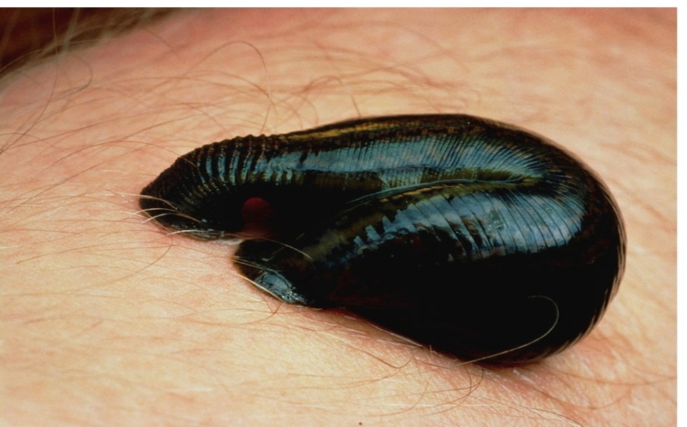
9. Write the type of symbiotic relationship that you can observe in the above picture.
a. Commensalism
b. Mutualism
c. Parasitism
d. Neutralism
11. Choose the incorrect sentence.
a. Echolocation is a process by which the bats can see objects through light.
b. Animals with visible ears has patterns on the hair of their skin.
c. Birds have visible ears which are covered with feathers.
d. Ears do not help the tiger to catch its prey.
12. Drone is other name for –
a. Soldier ant
b. Queen bees
c. Female bees
d. Male bees

